# PATCH 0: Description on how each of the changes (patches in the set) tie together (no diff)

Extract Classes will be implemented to split the responsibilities from a large class ControllerView. This class contains multiple methods with different responsibilities as well as inner classes

The first patch will remove the inner classes such as NoteOnScreenCollection and NoteOnScreenIterator from ControllerView and create java classes for them. See figure below before changes

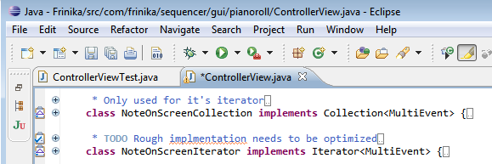

In the second patch, related methods will be grouped together and copied and then the copied data will be placed to a new class. See figure below before changes

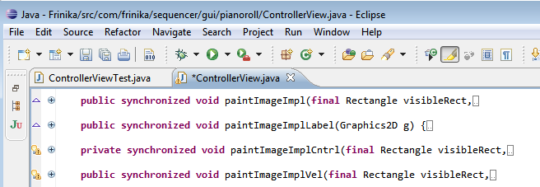

In the last patch, Move Field and Move Method will be implemented where all fields and methods that are defined in the new classses will be removed from ControllerView